**Salary Prediction based on job description features.**

## **Introduction**

For this salary prediction project I examined different attributes of employee information to predict their salary

## **Data**

The data is part of an existing data set that includes employee information. The features of the dataset include job id, company id, job type, degree, major, industry, years experience and miles the employee lives from from the metropolitan city. The size of the dataset is 1,000,000 rows.

### **Dataset: Description of features**

* **JobId**: Job Identifier Used to track the jobs.(Unique key)
* **CompanyId** : Anonymized company data of the job.
* **JobType** : Position within the company(Categorical)
* **Industry** : Industry of the job.(Categorical)
* **Degree** : Level of degree of candidate in the job.(Categorical)
* **Major** : Major of the degree in.(Categorical)
* **Years of Experience** : Experience of candidate in years.(Numerical continuous)
* **Miles from metropolis** : Distance from the nearest metropolis.(Numerical continuous)
* **Salary** : The variable which we need to predict .(Numerical continuous) Also defined in thousands.

## **Preprocessing**

For the data cleaning process, I followed the steps listed below.

* Removed 5 rows where salary equaled 0, which indicated missing values
* Removed the outliers, salaries in more than 75 percentile which constituted to 7117 rows i.e 0.7% of total data.
* Records with a degree and major listed as "None" were replaced with "OTHER"

## **Exploratory Data Analysis**

During the analysis of the dataset we where able to find out that there is not much variance across the different company id’s and hence can be ignored while building our model.

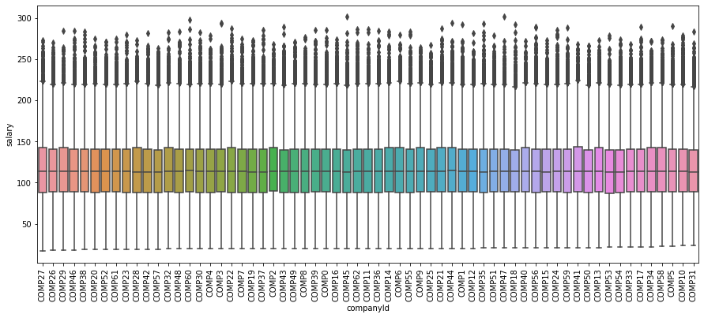

From the image below we see that employees having doctoral degrees are paid more compared to other employees.

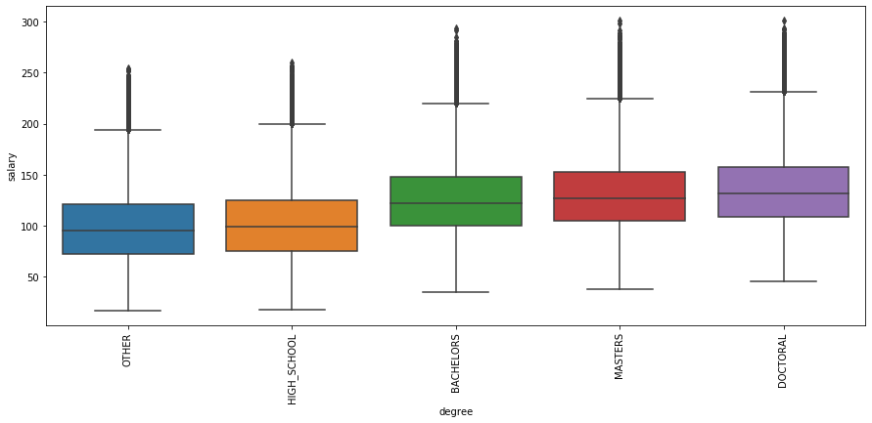

The below box plot shows the comparison between salaries among different job positions. And from the plot we can say that C-level executives are paid more compared to others.

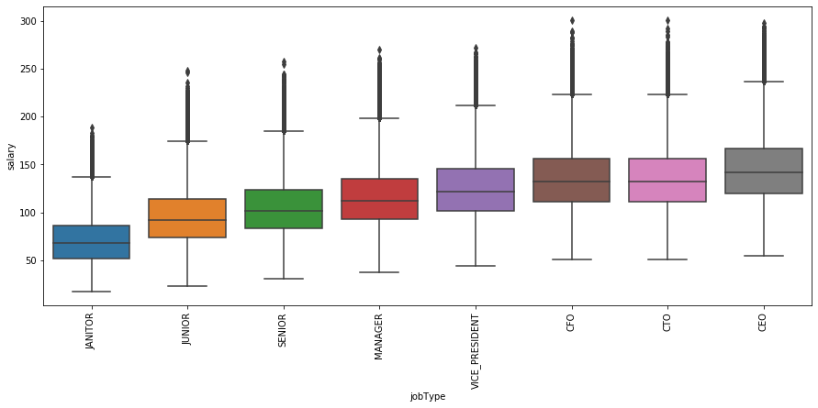

Is there a difference in salary among different industries? Yes, there is from the box plot we see that the Oil and finance industry are paid more compared to other industries.

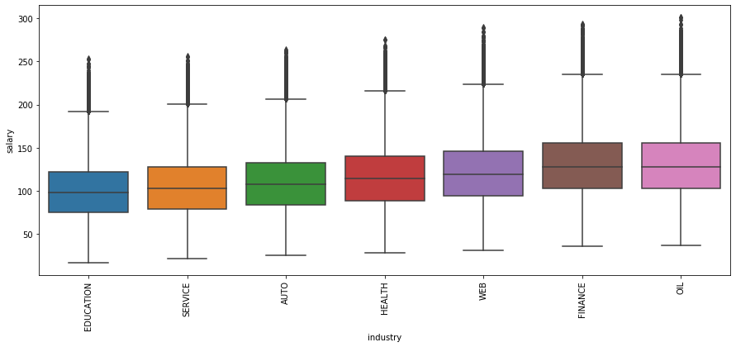

Salaries tend to increase as years of experience increases to test this we plot a line graph of salary vs years of experience and from the plot below we see that salary and years of experience are linearly dependent.

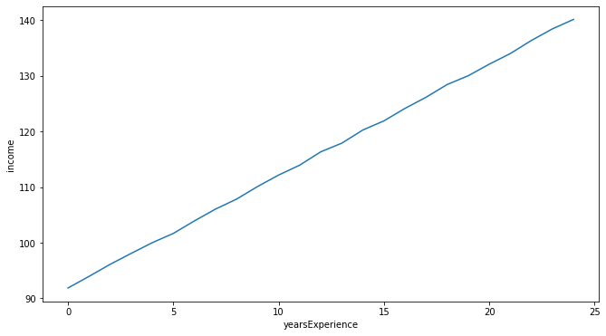

The line plot below also shows almost a linear relationship between miles from metropolis and salary but in this case as the miles increases from metropolitan area salary decreases.

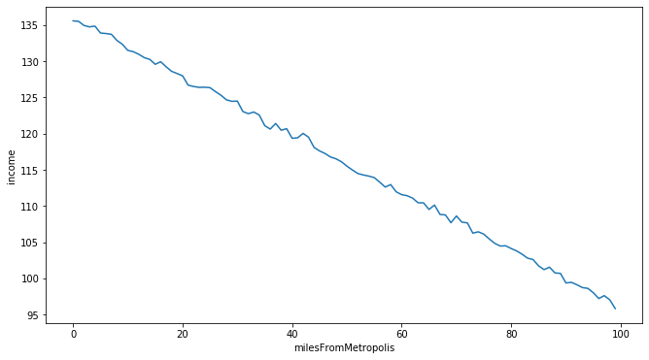

## **Modeling**

After examining the data, I removed outliers below the 25th and above the 75th percentile, keeping the inter quartile range. This resulted in 992,418 records in our dataset.

After reviewing the EDA process, I established the following features as predictors for training the model.

* Removed Company Id as there was not much variance among the companies
* Selected jobType, degree, major, industry, miles from metropolitan and years of experience
* Encoded all categorical variables.(using dummy variables)
* This brought us to a total of 31 predictors

I split my dataset into 70 – 30 percent ratio for my training and test data set respectively.

The regression models used to predict our result was Linear Regression and Random Forest regression.

|  |  |
| --- | --- |
| Model | Performance |
| Linear Regression | 384(MSE) |
| Random Forest Regressor | 366(MSE) |

From the performance we see that Random forest regressor performs better compared to the linear regression model, the performance of linear regression can also be improved by using polynomial features which would help fit the non linear relationship between feature and a target

## **Summary**

To end with we see that the Random forest regression model fits the data the best and is able to get a good error metric of 366 which is a very reasonable estimate as compared to our baseline error metric where we used the industry average perspective.

We also created a pipeline that takes both the training and the test scripts and tunes the model and saves the test outcomes to a csv file.

Some features that the dataset can include for better predictions are :

* Company Jumps: A person changing companies more frequently tends to have a higher salary due to hikes.
* Years within the company also can be a good factor.